Aircraft Wiring for Smart People
~ A Bare-Knuckles How-To Guide ~
10 September 2004

Abstract
This is a step-by-step, Foolproof 100% Gonna Work guide to wiring your airplane simply, effectively and inexpensively that builds on one basic principle: people who build airplanes are smart folks who can do things. This booklet is about how to make our electrical systems simpler and easier to install.

Introduction
Flying around the country installing EFIS and Autopilot systems I’ve met a lot of builders. I’ve hung out in their shops, drank their beer and wired a lot of airplanes. I’ve also heard the same questions about how and when to use certain techniques, what to ground and what not to ground, how to size breakers and switches, whether to crimp or solder, and why some antennas pick up Radio Moscow but not the local AWOS.

This booklet will show you how to wire your airplane so that it will work right the first time and teach you enough of the How’s and Why’s so that you know what you did and why you did it. This isn’t about all the possible ways to accomplish the job – it’s about one, Foolproof 100% Gonna Work way. The idea here is to find a method that’ll work in all cases, and just cop out and use that method instead of trying to make everyone into an engineer. (There are only so many the world can stand!)

It’s also time for a change. With few exceptions, homebuilts are wired like WW II fighters, and electronics have come a long way in 60 years. A two-year-old laptop may be old news, but up in the cockpit it’s still 1939. Take a moment and think about a modern car compared to a modern light plane. A single keyswitch and automatic overload protection versus a stack of breakers and switches and a bundle of wiring to choke a horse. Does your car have an Avionics Master switch for its half dozen computers and on board FADEC?

Circuit protection can be made automatic, switches can serve as indicators, and less panel clutter means Easier To Use. We can do better!

Table of Contents
Abstract 1
Introduction 1
Table of Contents 2
How To Use This Booklet 4
Start Here 4
12 or 24 Volts? 4
How Many Batteries? 5
One Alternator or Two? 5
Firewall Connectors 6
Full Auto, No Manual 7
Step By Step, Piece by Piece 8
Electrical Theory, Just a Quick Bit 8
Voltage 8
Current 9
Power 9
Resistance 9
RF and Noise 10
Power and Ground 11
The Evil Ground 11
Sizing Wires and Breakers 11
Radios and Indicators 12
Antennas 12
Kinds of Antennas 12
Safety Note About Transponder Antennas 14
Spotters Guide to GPS Antennas 14
GPS Antenna Mounting Tips 15
Audio and Entertainment 15
Back to Grounding, Again 15
Shielding 16
No Common Paths 16
EFIS, Autopilot and Other Digital Devices 17
Engine Monitor, FADEC and Sensor Wiring 17
Tool Time! 18
Solder and Flux 18
Heat Shrinkable Tubing 18
Snakeskin 18
Digital Volt Ohmmeter 19
Automatic Wire Stripper 19
Flush Cutting Dykes 20
Coax Stripper For BNC Connectors 20
Daniels Crimping Tool 21
Soldering Iron 21
Desoldering Pump 22
Solderless Splices and Terminals 22
Hookup Wire 23
Size Matters 23
Color Is Better Than Black and White 23
Twisted Pairs Are Easy to Trace 24
Coaxial Cable 24
Connectors 25
Power Connectors 25
Battery and Alternator Connections 25
Coax Connectors 26
Learning To Solder 26
Foolproof 100% Gonna Work Technique 27
The Standard Drawing 27
The Drawing for Your Project 27
Finding Problems and Correcting Mistakes 27
Foolproof 100% Gonna Work Power System 27
Power Board Design and Artwork 27
Mounting the board 28
Master Switch 28
Alternator output 28
Switched loads 31
Avionics Master and Backup Battery 32
Avionics Loads 32
Flaps, Pitch and Roll Trim 33
Flap and Trim Motor Voltages 33
Wiring a Motor Reversing Switch 34
Warning System 34
Power Board Schematic 36
Where To Get Parts, Tools, Etc. 36
Where To Get Parts, Tools, Etc. 37

How To Use This Booklet
According to my friend the Adult Education Expert, the way to get the most out of this booklet is to flip through it and look at the pictures, and see what looks interesting. Next, read the next section, entitled Start Here, and finally read through once to see what’s what and get a feel for what we’re going to talk about. Don’t try to remember everything, just buzz through it like a story.

Once you’ve got a feel for the tools and the techniques at an overview level, work through the example in Foolproof 100% Gonna Work Example and cross-reference anything that doesn’t make sense with the section that talks about it. Go ahead and make notes directly on the drawings – the PhD education types say that this is supposed to help a lot, and gives you and me an excuse to doodle in the margins.

Having read through, worked through the example, made your notes and re-read the stuff that didn’t come in clearly the first time, you’re ready to work out your own plan in the Foolproof 100% Gonna Work Method.

Pretty soon you’ll be helping other guys with their projects, which is specifically what I have in mind. This is something that we, as a community, should be able to do well.

Start Here
These next topics are the decisions builders agonize over (and debate without end) when wiring their planes, so we’ll get ‘em out of the way first so we can get down to business and do some real work. The question to be answered is: “If we weren’t already doing it this way, how would we want do it?” This will give you a good idea of where we’ll be headed in the rest of the booklet, so let’s take a look.

12 or 24 Volts?
Cars are twelve (12) volts, airplanes are twenty-four (24). There you go, easy enough.

Here’s my take:

As of mid-2004, just about anything you can buy in avionics will run on 10-32 volts DC and doesn’t care either way. Single voltage items like landing lights and strobes can be all be had in 24 volt versions now, so that’s a not an issue either. If you need a jump start, most FBOs are used to wheeling out the start cart for King Airs, Citations and such that are all – you guessed it – 24 volts.

Here’s yet more detail for you:

- Since a given load draws half the current at 24 volts that it does at 12, you can use smaller wire with the same results. You can use wire that’s only ¼ the size, which is a pretty big deal when you ‘re running #18 and everyone else if running #14. Most small planes have nearly 50 pounds of wire in them. How’d you like to save 10 pounds of dead weight?

- Engine start will drop a 12-volt system down to around 9 volts causing EFIS systems to reboot, radios to lose presets and fuel totalizers to restart. A 24-volt system will only drop to about 18 volts during engine start, which is well above the 10.5-volt minimum for modern avionics. No backup batteries, no switching, no relays, and no fiddly, complex systems to solve a non-problem.

- A 24-volt system also has a LOT more reserve energy available for use than a 12-volt system. As in point #2, a failed alternator in a 12-volt system leaves you 2 volts from shutdown. It a 24-volt system you’ve got a lot more reserve before your avionics and FADEC drop offline.

The bottom line is the higher the supply voltage, the better off we’re going to be up to a point where it starts to get dangerous. Quite a lot of telecom equipment runs on 48 volts DC, which is close to an optimal trade-off between voltage and safety.

If you’ve got to go 12 volts, that’s fine, no biggie. We’ve just got to allow for a few extra things that 24 volts systems do as freebies.

How Many Batteries?
If you go with 24 volts, that’s an easy answer: One. There’s a current fashion in backup batteries and essential bus designs, which I think is overkill. If you have a battery with enough grunt to start your engine, it’ll run your avionics for longer than you can remain aloft

The real issue is if there’s a main bus fault or short, then everything drops and you’re in trouble, right? Traditionally that’s true, but there’s a simple way around it:

Provide multiple busses, not multiple power sources!

Just like your house, car and computer, multiple busses and breakers solve the problem, not multiple power sources. How many people do you know who have more than one Power Company feeding their house?

If you have a 12-volt system, you’ll need a small backup battery to give you some margin of reserve, but that’s easily done, and doesn’t weigh all that much.

One Alternator or Two?
One is plenty for almost all applications. If you have a good Alternator and regulator (I like the B&C stuff, it works well and the support is outstanding) the most likely reason for failure is bad wiring or overload. Either way, bringing another alternator on-line will probably just feed the fire.

If you have a big, 24 volt battery as discussed above, why bother with a backup alternator? The battery will carry your avionics and engine systems for hours. The only exception would be if you had high current draw, critical loads like de-ice boots or a hot prop to keep running. In which case, you really do need a second alternator. Might be a good idea to hang it on a second engine if you’re planning on a lot of that kind of flying!

Secondary alternators are a neat idea, but with a single engine it doesn’t really buy you that much more time aloft, and almost always buys you none at all.

Firewall Connectors
The time has come to go through a firewall, so how do we do it? By drilling a hole. There’s a school of thought that favors swoopy, round, metal MIL-type connectors, and matching sub-harnesses but I’ve found that it takes a Swiss Watchmaker to put them on correctly, and then another day or two to find out which pin got wired wrong. You can usually tell by the burned smell but … OK, that’s not funny. Sorry about that. By building the whole airplane harness on the bench and dropping it in the airplane, there’s no need to ever remove the harness. And how often do you take off your firewall?

Anything that is serviceable and removable should have it’s own Molex Connector located close to it. What good is a big connector on the firewall when you need to pull your alternator or igniter box?

Just run the harness through the firewall, use a nylon bushing to make sure nothing scratches or chafes and you’re all set. If you do avionics wiring for a living, round MIL-type connectors on the firewall are very pretty. My contention is a homebuilder who will install three or four of them in his/her life will probably get two or three of them bugered up as part of the learning process. Not a good thing for reliability, but that’s my opinion, right?

Full Auto, No Manual
War Story Time: I’ve worked on a few homebuilts that are all but impossible to operate without recurrent training at Flight Safety every few months. On one very sexy homebuilt that rolled in to the shop you’d have to throw six (6) switches and press in four (4) breakers to get the EFIS to come up in normal operating mode. I never did understand the various emergency modes – they were beyond complex.

My thought is simple: No manual overrides, cross-feeds or other Apollo-13-wanna-be switches in the electrical system.

Here’s why:

Most private pilots fly less than 100 hours a year, and almost never practice system failure drills. If in an emergency “that which is not practiced is not performed”, there’s real harm in putting complex manual features in an electrical system that can get you in more trouble than you had.

The first task in an emergency is to “Fly The Airplane”, which is probably a better idea than trying to remember how to bring another alternator on-line and cross feed your essential bus from a backup system while not blowing your remaining breakers. This sort of thing can be made automatic by simply designing for it, so there’s no need for the manual overrides. How do they do it on cruise missiles and satellites where there’s no one to operate the electrical system? The same way we’re gonna do it here!

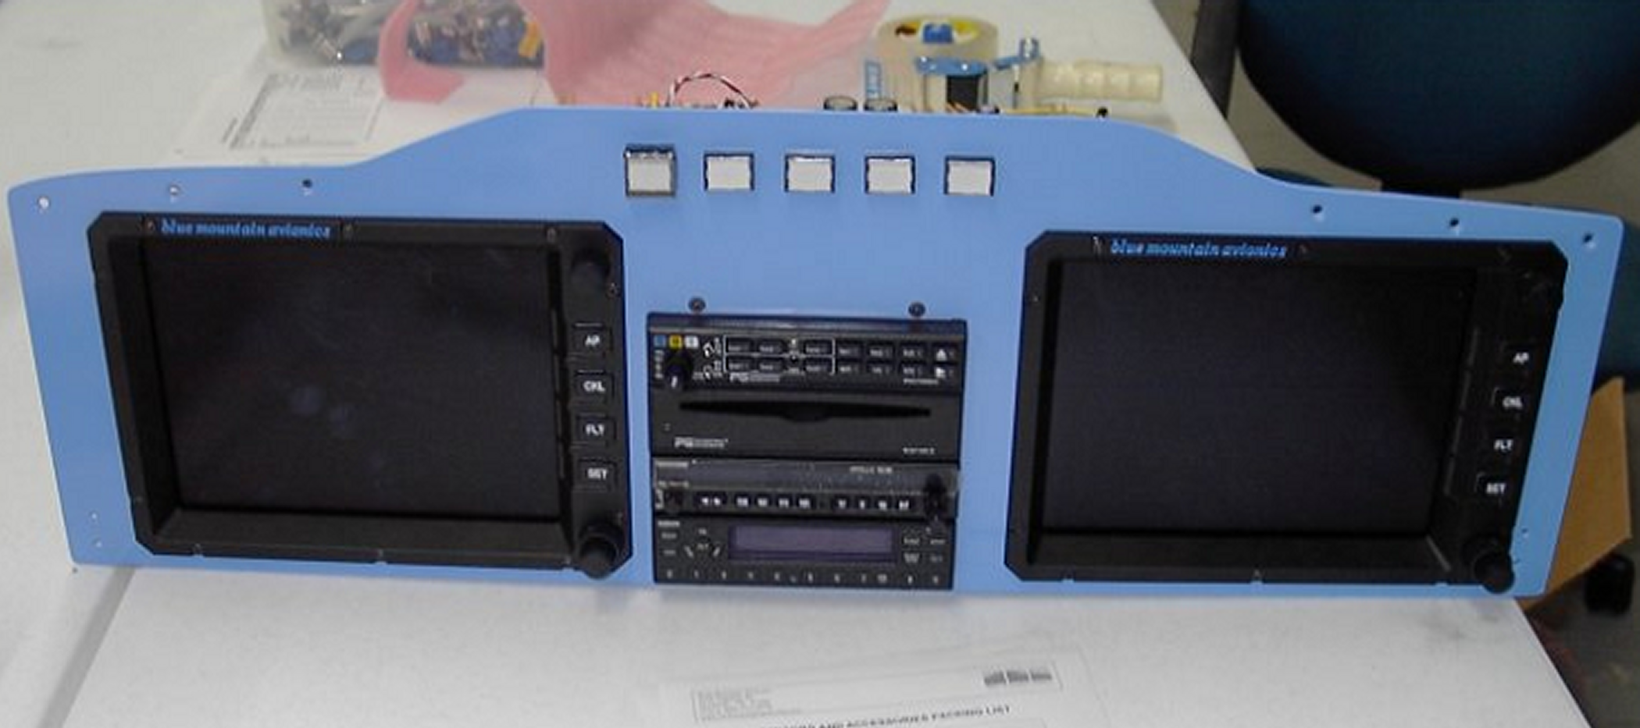
Step By Step, Piece by Piece

There are six (6) fundamental kinds of things you’re gonna have to deal with when wiring:

- Power and Ground
- Radios and Indicators
- Audio and Entertainment
- Antennas
- EFIS, Autopilot and Other Digital Devices
- Engine Monitor, FADEC and Sensor Wiring

Each of these is a little different, and use different tools and connectors, so we’ll cover them one at a time. If you run into something new, like Satellite Weather for example, you’re ready. It’s got a computer like and EFIS and an antenna like a radio. After the next few pages, you’ll know what to do!

Electrical Theory, Just a Quick Bit
Before we get into how to do the work, we need a little theoretical basis. Just a very little bit, so stay with me.

Voltage
Everyone talks about voltage, but what is it, exactly? It’s the electrical equivalent of pressure – a 12 volt spark jumps less than 1/8 inch, but a 12,000 volt spark will jump an inch or more. Voltage is pressure. Guidelines:

- A regular D cell battery is about 1.5 volts
- A car battery is 12 volts
- An airplane battery is supposed to be 24 volts, but some are 12 like cars
- Most avionics will run on anything between 10 and 32 volts.

Current
Current is measured in Amperes, or Amps, and is the electrical equivalent of flow.

Guidelines:

- A 12 volt radio draws about 3 amps
- A 12 volt landing light draws about 10 Amps
- A starter can draw 150 Amps or more (800 for turbines!)

Power
Power is measured in Watts and is simply Volts * Amps. How much current times how much voltage is how much power. Guidelines:

- A 24 volt landing light drawing 5 Amps is using 5*24 = 120 Watts
- A 12 volt radio drawing 3 Amps is using 12*3 = 36 Watts
- 1 Watt dissipated in free air is warm to the touch
- 10 Watts in free air will burn your fingers

Resistance
If Voltage is like pressure and Current is like flow, Resistance is just that --l resistance to flow. Resistance is measured in Ohms and is equal to Volts / Amps. For a given voltage, the lower the resistance the more current will flow. Guidelines:

#18 wire has a resistance of 0.0064 Ohms per foot.
#22 wire has a resistance of 0.0161 Ohms per foot.
A good connection should read less than ½ an Ohm

Since the voltage measured across the wire is the Resistance of the wire times the Current flowing through it, you can see that you’ll lose some voltage, and lose some precious power in your wiring. Take this example:

A 10 foot chunk of #18 is carrying 5 Amps to run our transponder. Ten feet of #18 has a resistance of 0.064 Ohms, which means we’ll drop 0.064 * 5 = 0.32 volts in each wire, both power and return. This means of the 12.5 volts you’re sending to the transponder, the transponder only sees 11.86! Not a big deal, but when the battery gets low, it doesn’t leave you a lot of margin. The voltage drop is only ¼ as much at 24 volts, and you have a lot further to go, but I believe I beat that horse enough for one day.

To Review:

Power in Watts = Volts * Amps (Voltage across it times the current through it)
Volts = Ohms *Amps (Resistance of it times current through it)

Knowing this much, you can figure out just about anything in a DC circuit:

- What is the voltage drop in a 10 foot piece of #22 wire carrying 5 amps?

Ohms = 10 feet * 0.0161 Ohms per foot = 0.161
Vdrop = Ohms * Amps = 0.161 * 5 = 0.805 volts

- How much power is lost in that wire?

Watts = Volts * Amps = 0.805 * 5 = 4 Watts (the wire would be warm touch!)

- A 24 volt radio draws 5 amps on transmit. What is the equivalent resistance of the radio?

Ohms = Volts / Amps = 24 / 5 = 4.8 Ohms

This means the radio acts just like any other 4.8 Ohm resistance.

This is good background, but since we’re wiring power with #18 at 24 volts, and using 10 amp breakers on everything, you don’t have to worry about it. It’s handled, but now you know.

RF and Noise
Everything we’ve talked about so far is DC (direct current) circuits, where a voltage drives a load of a known resistance. This covers 98% of aircraft wiring, and good thing too.

The other 2% are AC circuits, which you’ll just hook up and otherwise not have to mess with. AC alternates between positive and negative and looks like a since wave on a ‘scope. Radios and digital devices are full of high frequency AC, and Radio Frequency AC is called “RF” for short. Shielding is used to keep RF inside, in the case of coaxial cable, or outside in the case of shielded audio circuits. By following this booklet, RF and noise suppression is something you can say you heard about, but don’t have to deal with.

We’ll cover it in detail when we get to Audio and Entertainment.

Power and Ground
First off, we’ve got to power the thing up, whatever it is, which brings me to Kirchoff’s Law, which simply states that whatever electric current goes into something, has to come back out and return to the battery. Which means anything you power up needs two wires to make it go – one for Power and one for Return. This brings us to:

The Evil Ground
In a car or metal airplane some wise soul thought it would be a good idea to just use the chassis or fuselage as a common Return wire and save a few bucks. Great idea, if you want to spin motors and make lights blink in a Model T, but not so good for delicate electronics like EFIS, Radar, electronic engine monitors or FADEC. Both Electronics International and blue mountain avionics specify ungrounded EGT probes because most homebuilt airplanes have grounds all over the place and the stray currents that go with them can cause odd EGT readings.

“Bad Grounds” cause more problems than just about anything else.

So -- I offer the Zen solution of not making any grounds. Ditch the whole, outdated, tragically useless concept. If you stick to the two-wire rule, one for power and one for return, you’ll never have a ground problem, and everything you connect will work the first time. This brings us to our second rule:

Rule #2:

All circuits are wired with a power lead and a return lead of the same size. Power is color-coded yellow or red, return is color coded black.

Color-coding is done in every branch of electronics except for light aircraft to make things easier. We’re gonna start doing it too.

Sizing Wires and Breakers
We did a fair amount of figuring in the section above, which we can reduce it down to a simple rule:

Breakers are 10A for everything wired with #18, which is almost everything.

If you have a load that draws more than 8 Amps, you need to put it on a separate breaker. There are very few of these in practice, generally alternator output, landing lights in 12 volt systems and some gear pumps. Breakers should be loaded to less than 80% of their capacity, so the rule holds.

8 Amps * 24 Volts = 192 Watts, which is quite a lot of power.

A common practice in homebuilding is to size the breaker to match the size of the load. This sort of makes sense, but when you think about it, it really doesn’t. The breaker is protecting the wiring, not the device being powered! If the wiring shorts out, we want the breaker to pop instead of melting the wire – right?

But, you say, the automotive industry use different sizes of fuses!

True enough. They use different sizes of wire too, because auto fuses are all one price while copper wire is priced per pound used. What makes good sense in high volume production isn’t always the best method for one-off projects. For us homebuilders, simple and safe is what we’re after.

Radios and Indicators
This covers wiring everything from a basic Nav/Com to EFIS, Autopilots and Radar. The signals you’ll be dealing with here are low level (less than a volt) and are susceptible to noise and interference. Wire all of these with #22 Teflon wire, and shield microphone, headphone and speaker leads. Shields are to be connected at the radio end only, and cut flush at the other end using your Flush Cutters. Power and Return are #18 in the usual colors.

The manufacturer provides a standard drawing for the radio and indicator you bought, the only thing I can add is this:

Make sure you leave enough cable length to be able to take the indicator out of the panel and still connect and run it. These sloppy lengths of cable are called Service Loops and make the mechanic’s life easier and your bill lower when it comes time to fix it. Anything you build, imagine having to take it apart and fix it later!

Antennas
Antennas are used to couple one circuit to another at a distance. Anyone who says otherwise is probably selling something. What we want in airplanes is to couple our transponder to a ground controlled radar station, to couple our Com radios to other Com radios and to get our Nav radio hooked up to the local VOR. Antennas come in a bewildering array of choices, so I’m gonna show you which ones work 100% of the time with no problem and save you the Learning Experience.

Kinds of Antennas
There are three frequency bands of interest for airplanes: VHF, Microwave and Long Wave.

- VHF is for Nav, Com, Localizer, Glideslope and Marker beacons. All the 1950’s era about-120-MHz stuff you tune with an aircraft radio. These antennas are connected with RG-142 coaxial cable and BNC connectors.

For a metal airplane use a commercial whip antenna and make SURE that the bottom of the antenna is connected to the skin of the aircraft. No paint, oil, or any other yuck. This needs to be a solid electrical connection. Take the end of the coaxial cable that goes to your radio, and measure with an Ohmmeter from the shield to the skin of the your airplane. It needs to be pretty close to a dead short, since the shield is bonded to the skin of the airplane at the antenna. Most antenna problems are caused by either connectors put on badly, or open shields. Check yours and make sure it’s good.

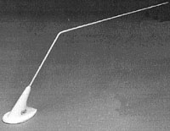

The antenna shown above is the AV17 from Aircraft Spurce and is commonly seen on Van’s designs.

For a composite airplane use a dipole. This is a vertical that has another vertical element to balance it since there’s no metal aircraft skin to connect to it. These antennas always work, and almost never give problems.

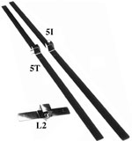

The ones shown in the picture are from Advanced Aircraft Electronics, and work very well. Aircraft Spruce usually has them in stock. Just bond them in to the airplane, and forget about it. Jim Weir has plans for making a similar antenna with copper foil, although I’m partial to the AAE version.

Remember: COM is vertical, NAV is horizontal! Follow AAE’s directions and you’ll be in good shape.

- Microwave is for Transponder, Strike Finder, GPS, Satellite weather, Cellular phones and all the creations of the last few decades. These are typically connected with BNC connectors, but use RG-142 for lower loss at frequencies near 1000 MHz.

Microwave antennas are best supplied by commercial sources since their active elements are so small making them is a real chore. Most microwave antennae require a ground plane like an aluminum airplane skin under them to work properly. If you are installing one of these in a composite airplane, either ask the manufacturer for an antenna that will work in a composite plane with no ground plane, or spray a ground plane using Super-Shield.

Super-Shield is basically metal foil in a spray can. Shoot three (3) coats of it on the outside of the plane, mount your external antenna and it’s just like having a metal airplane without all the rivets. You can even paint over the stuff once the antenna is installed and no one will be the wiser but us.

http://www.mgchemicals.com/products/841.html

Safety Note About Transponder Antennas
A transponder puts out a couple hundred Watt microwave pulse in a frequency band that is none too healthy to be around.

On a metal airplane this is no big deal, since the whole thing is one big, shielded can. On a composite bird, you can be sitting unpleasantly close to a powerful microwave transmitter, which is Not Good. Mount the antenna as far away as practical, or failing that, use SuperShield to shoot a ground plane between you and the antenna. One of my friend’s airplanes actually has the antenna right under the pilot’s seat!

Spotters Guide to GPS Antennas
GPS antennas come in two flavors, active and passive. Active antennas take a voltage (usually 5 volts DC) up the coax to power a small preamplifier in the antenna. Most Garmin GPS antennas are this variety, as are any of the small, plastic stick-on types. Active antennas are small enough to put inside the airplane on the glare shield or in the composite structure and are often hidden. Passive antennas are usually mounted on the skin of the airplane, and if the GPS receiver can has the gain to use them, can provide excellent performance.

If you’re not sure which kind you have, or which kind to use, take your voltmeter and measure the voltage from the center conductor to the shell of the BNC connector on your GPS receiver. If you see about 5 volts, you’re looking at an active antenna.

Most passive GPS antennas look like short circuits at DC and will short out a GPS receiver that is set to drive an active antenna. Best bet is to use the one the manufacturer sent with the radio.

GPS Antenna Mounting Tips
When mounting GPS antennas make SURE that there are no obstructions that block the sky. Imagine the bottom of the antenna sitting on a round plate ten (10) feet in diameter covered with a matching 10 foot dome. What’s it gonna hit? If it’s metal, that’s a part of the sky you won’t see. The vertical tail isn’t wide enough to signify, but a chunk or glareshield or the top of the wing sure is!

Common troubles are putting them partially under a metal glareshield, beneath carbon fiber, or in the cockpit of a high wing design. GPS can ‘see’ through fiberglass, but not carbon, and certainly not aluminum. Got it next to another antenna? That’s a chunk of sky you’ll miss too!

You should be able to see 10-12 GPS satellites while flying, but 6-8 is much more common, I’ve found. Taking a little time to locate the antenna where it has an unobstructed view of the sky will gain you a world of performance.

- Long Wave is for ADF. This is for tuning NDBs and AM broadcast stations and is the oldest of all the flying radios. Since the FAA is slowly killing off all the NDBs, we won’t cover it here in detail. If you have to hook up an ADF, treat it like VHF and you’ll be more than fine.

Audio and Entertainment
I rather enjoyed the look on my mechanic’s face when she turned on the strobe pack and igniters and noticed that no difference in the Mozart playing in the headsets. “Jeez, that’s quiet” she said. Same thing for radio transmissions “Sounds like FM” she says. There’s no need for alternator whine, strobe noise or any other audio crackles and crunchies in an airplane any more than there is in a home theater system. Here’s how you make it quiet:

Back to Grounding, Again
The guys at PS Engineering at just north of my shop in Tennessee are a sneaky bunch, I think. They put a solid ground bar on the back of their audio panels and ask you to solder all the “grounds” right there. There’s a crew who isn’t going to have any problems with ground loops! Your audio circuits should follow the same rule as all the others:

All circuits are wired with a power lead and a return lead of the same size.

This means that microphone, headphone, CD and everything else gets connected with two leads and that the Return leads are all connected to this audio “ground bar”. Doesn’t matter where or what it is, as long as they all go to one place. The PS Engineering crew has a lovely drawing in their installation guide that worth looking at for an example of how to do things well.

Since we’re wiring our circuits in pairs, grounding is not a problem we have to solve anymore. There is no ground.

Shielding
As mentioned in the section on RF and Noise, shielding is what we use to keep the wires from acting as antennas and either radiating or receiving unwanted RF. By using shielded wire for microphone, headphone, speaker and any other circuit carrying audio and connecting the shield to the ground buss described above you’ll essentially have no problems ever.

Make sure you connect the shield at the ground buss end and cut it off flush at the other end.

If you don’t the shielding won’t work and you’ll not be pleased. Which brings up a couple more rules of thumb:

If you want it quiet, give it it’s own lead and shield it.

Shields are connected at the source end, and cut off flush at the load end.

No Common Paths
Shielded leads will keep things separate, but that also means running separate cables for separate signals. Specifically, keep these signals on their own cables:

- Each headset
- Each microphone and PTT
- Each audio source (CD, cellphone, etc.)
- Speakers

This approach has you running a few more cables, but gets you the perfect result every time. You can use the same kind of Teflon insulated, shielded six (6) conductor cable for each of these. As an added bonus you’ll use the same kind of cable for your engine sensors, so you’ll get good at working with it.

EFIS, Autopilot and Other Digital Devices

Engine Monitor, FADEC and Sensor Wiring

Tool Time!
Before we get into the How’s and Why’s, we need to get familiar with the tools we’ll be using and the materials we’ll be using them on. Read on – it’s a lot simpler than you’d expect, and all of this stuff can be had from the sources at the back of this booklet.

Solder and Flux
Good solder comes as a spool of soft wire and is 63% Lead and 37% Tin called, not surprisingly, 63/37 solder. The flux that fills the hollow core of the solder cuts through the oxide layer on your wire and connector so that the solder will wet out and flow easily. Kester 44 is s good one, and comes in 18 Gauge for big stuff, and 23 gauge for fine work.

You’ll sometimes here the term “rosin core solder” which generally means any solder that has a non-acid organic flux core. The stuff I prefer cleans up with water, and the smoke won’t sting your eyes when you solder with it.

For soldering big lugs for your battery and alternator leads the flux core in the solder may not be enough. Kester makes a good liquid flux that rinses clean with water. We’ll cover this in detail in the soldering section, but we do wash everything in water to remove excess flux and leave a clean, shiny joint. By the time you get through this booklet you’re gonna be good at this!

Heat Shrinkable Tubing
This stuff is great – solder a connection, sleeve it in heat shrink, and it’s airtight and good as gold. We use heat shrink for covering splices and the ends of uninsulated connectors. The good stuff has glue inside that melts when you heat it up to form both a water and airtight seal, like 3M EPS-300. Digikey P/N EPS333-16K is one size of this tubing, which is available in many sizes.

Snakeskin
This knitted cable covering make the difference between an OK and an exceptional looking installation. Put your spun leads inside this, and you’re on your way to a truly gorgeous, and easily repaired, airplane.

Digikey P/N AG120NF12B-100-ND is made by Alpha Wire and looks like this:

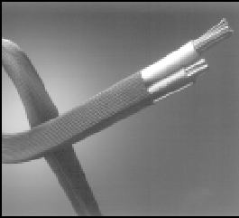

Digital Volt Ohmmeter
You don’t need anything super-duper here, but you do need something that can measure DC Volts, Ohms and has a continuity checker that beeps. Anything else is gravy for this kind of work. I’m very partial to Fluke, but then again I’m a geek and use my DVM like an A&P uses a wrench. Harbor Freight has what you need for less than $50. Make sure:

- The thing is digital

- That it autoranges – you should be able to read it without having to remember to multiply by 10 or 100 or whatever.

- That it doesn’t have a zero adjust for the Ohms ranges: good ones are automatic

- That is has a diode checker – they almost all do this now, and it’s a nice feature

- It has a beeping continuity tester – you’ll use this a lot

- $50 will get you a decent one, $150 will get you a great one, $300 will get you the one I use in the lab that has a laptop port and a book full of features.

Automatic Wire Stripper
An automatic wire stripper saves time, money and frustration and is cheap, cheap. Nicked wires caused by bad manual stripping are about half of the broken connections I see, and this thing makes sure you get it right every time. There are various different types to fit every budget. The one pictured below is very nice, and can be had from Digikey or Allied.

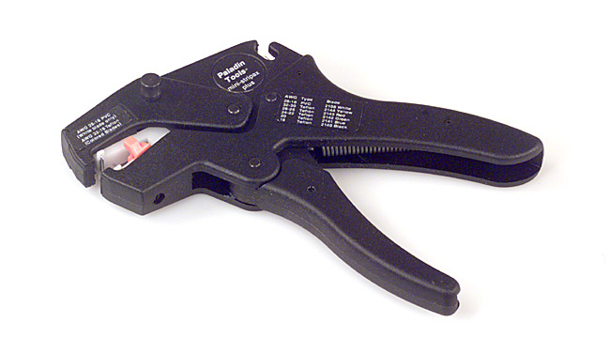

Flush Cutting Dykes
These are the normal ‘wire cutters’ that everyone uses with a twist – they make a flush cut with no burr. It’s the avionics tech’s secret weapon for a really nice job. Make sure you get a good set with cushioned handles and a spring that pops it open when you let go. Makes a real difference in fatigue at the end of the day. Don’t let anyone cut safety-wire with these – the jaws are not hardened to cut steel wire, and it’ll nick them badly and they won’t cut clean anymore. My personal favorite is from Xcelite, and is a full flush cutter. Fry’s or Digikey has ‘em for about $6. The Cooper is shown below:
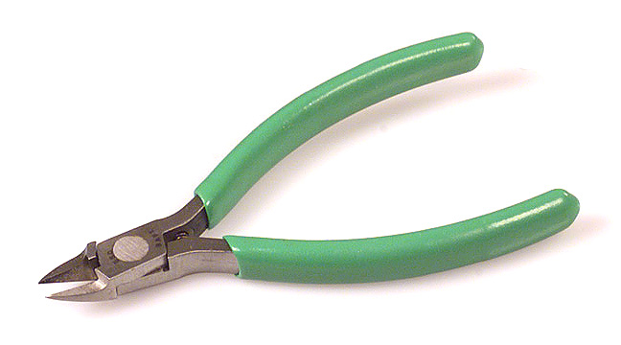

Coax Stripper For BNC Connectors
These nifty little gizmos strip the outer jacket, copper braid and inner insulation on coaxial cable in one go, and are available from several makers in varying price ranges. You won’t be doing too many BNC connectors, but for what it costs it’s cheap insurance that your connectors will all work right the first time. Failing that, borrow one from the avionics shop or cable TV guy.

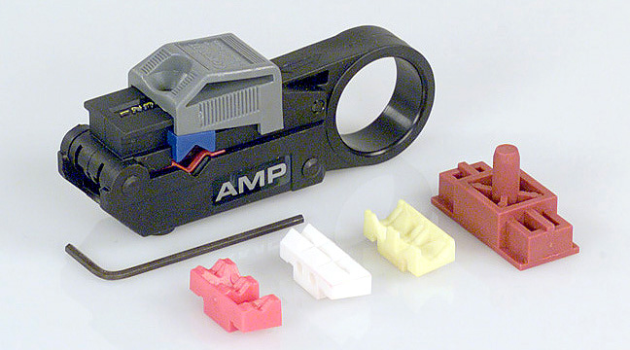

Daniels Crimping Tool
This is the one to use for all the D sub connectors you see on avionics. If you are farming this out, you don’t need it. These tools make a perfect crimp every time and are pretty expensive. It’s worth borrowing one for as little as you’ll use it, but use it you must, as there is no substitute.

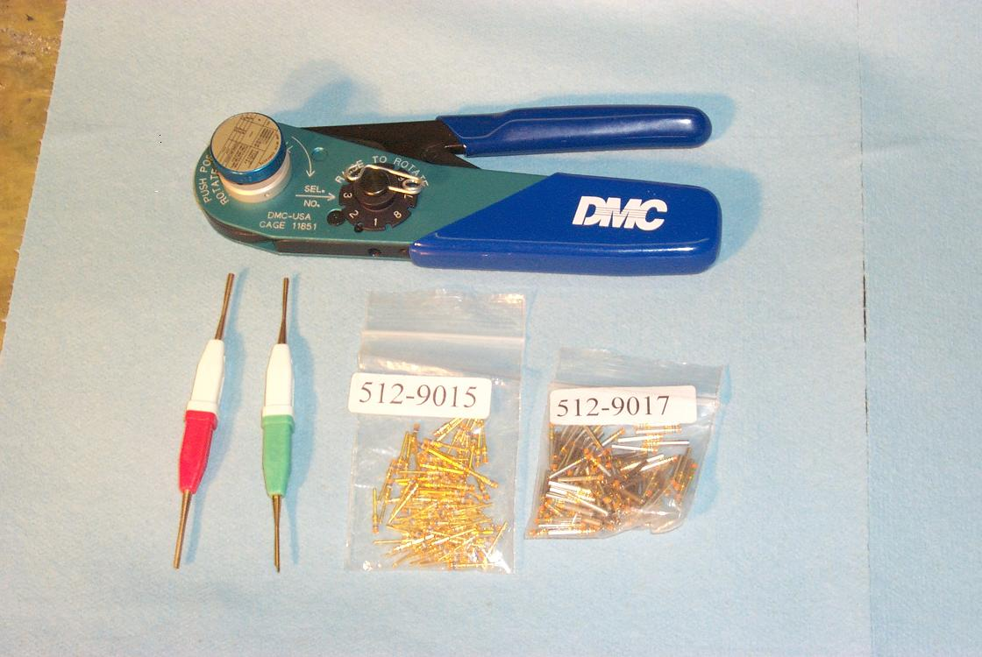

Soldering Iron
You’ll need a good soldering iron in the 35 Watt range. As usual, Digikey, Allied or any of the other should have what you need. A common one looks like this:
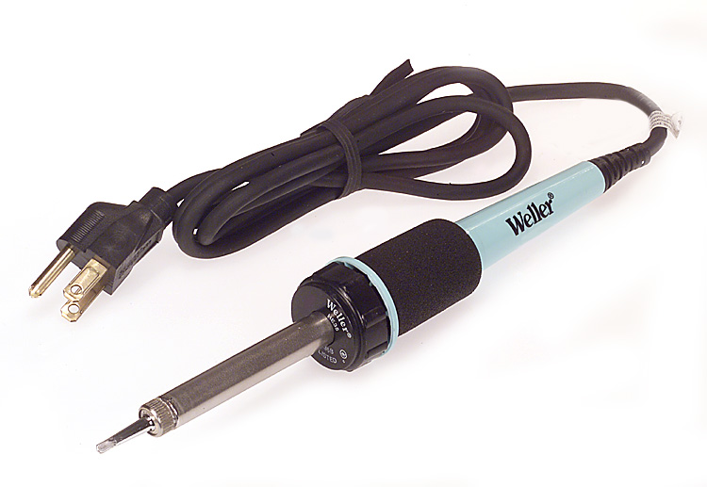

Desoldering Pump
You’ll need one of these for things you solder together and discover you didn’t mean to.
Digikey P/N PAL1700-ND is a good one, about $20

Solderless Splices and Terminals
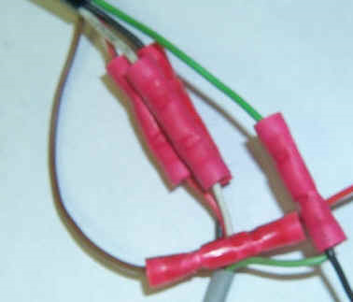
The automotive-style splices are HORRIBLE. Don’t use them for anything except filling a dumpster. In the hands of a real pro they can be just fine, but none of the pros I know use them, oddly enough.

If you need to make a connection, solder it and cover it with shrink tube.

I’ve spent more hours chasing bad Butt Splices and under-crimped Ring Terminals than I’d care to count. Soldering takes a little more time, but once it’s done, it’s done well and completely and that’s the last you’ll ever mess with it.

These are very popular, but here’s why I say pitch ‘em in the dumpster:

- A homebuilder won’t use enough of them to get good at putting them on
- You can’t inspect them to see if the wire is cut, over-crimped or broken
- These splices are, very often, used to cover-up a mistake that should be rewired anyway. Note the color code changes at the splice in the photo above. Makes for a long afternoon, somewhere.

A friend’s Cozy had FOUR of these things in a two-foot power lead. Took us hours to find the intermittent problem caused by one of them, and another 30 minutes to cuss the shop that did it. Just say no!

Hookup Wire
Everyone knows that Tefzel insulated wire is white, and you wire airplanes with it. As you might expect by now, I’m gonna disagree. Why make everything white? Can we possibly make the airplane any harder to work on? And why Tefzel? Tefzel and Teflon are chemically similar, except that Teflon handles cold better, is impervious to almost everything, doesn’t burn or outgas and is available in a zillion colors. Satellites are wired with Teflon. Military aircraft use Teflon. Kitplanes and General Aviation aircraft are still wired with Tefzel. You know why? Because old specs never die! Better stuff came along, but no one updated the spec. According to my DAR, Teflon is an acceptable substitute for Tefzel in all applications since it is better in all respects.

So we’ll use the good stuff, and in color – Teflon wire can be had from any of the sources in the back of the book.

Size Matters
With the exception of your starter and alternator cables, you only need two sizes of wire in your airplane: #18 and #22. #18 is good for 10 amps, and anything smaller than #22 can be hard to work with unless you do it every day. The rule is:

Use #18 for Power and Return, #22 for everything else.

Color Is Better Than Black and White
The following colors of Teflon wire to make things easy to trace and work on later.

Color | Meaning
Yellow | Power
Red | Power
Black | Return
Blue | Signal
Green | Signal
White | Signal

The rule is “the brighter the color, the higher the voltage” so Alternator output is Yellow while Alternator field is red. Both are power colors. Black is always return (ground if you must call it that!) and Blue, Green and White are used for signal leads as needed.

Example:

A tachometer sensor needs power, return and a signal output lead. I chose Red, Black and White. Just looking at the sensor on the engine I can tell which lead is which, and I don’t have to figure out how to keep wire labels from coming off under the cowl as time goes on and things get oily. Makes it easier!

Twisted Pairs Are Easy to Trace
If you are going to have two or more wires going to a single device, I say spin ‘em. Use an electric drill to twist them into a cable that’ll stay together and you’ll be amazed how much neater your bundles look, and how much easier it is to tie all this stuff down.

Just take your bundle, clamp one end in a vise, stretch them all parallel and fold your end over and twist. Put that twist in your electric drill and spin ‘em up. After they look like you want, give a gentle tug to stress relieve the bundle, and it won’t snap back when you let go.

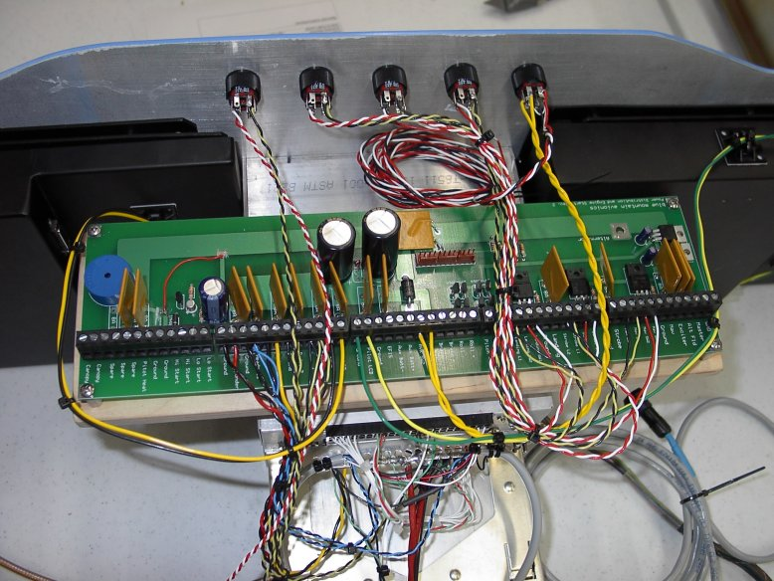
Spun cable sets and power board in N722

Coaxial Cable
Coax comes in several flavors, but to make matters simple and keep your tool investment to a workable minimum we’ll just pick one: RG-142. This is the copper-colored coax that avionics shops usually refer to as “The Good Stuff” and use on transponders and radar antennas. It’s the same as RG-58 in every way except it’s better: higher temperature, lower loss, everybody wins. You can use it on anything from GPS to ADF and it’ll work just fine.

RG-142 is a bit more money than RG-58, but you’ll usually come off cheaper wiring one airplane with all RG-142. Check this out: If you’re buying a minimum length roll of 250 feet of cable, you’ve got more than you need anyway. If it’s cheaper to buy just one roll of the good stuff!

RG142 is equivalent to RG-400, so either number gets you the same stuff.

Connectors

Power Connectors
The ubiquitous “Molex Connector” shows up all over the place. Your Whelen strobe packs have ’em, and every A&P in America has a box full somewhere. Molex makes a world of connectors (it’s almost like saying “Ford Engine”), but the ones aircraft people call “Molex Connectors” have three wires in them and go by these numbers:

Male Plug 03-09-2032 Pin: 02-09-2103
Female Receptacle 03-09-1032 Pin: 02-09-1104

These take the little pins specified above. The pins can be crimped on, and the ones above are good for wire sizes 14 – 20, which means our #18 fits perfectly. Use these to hook up strobe packs, trim motors, anything you may have to take out and fix, fiddle with or replace. These are used on certified aircraft, and are pretty easy to work with.

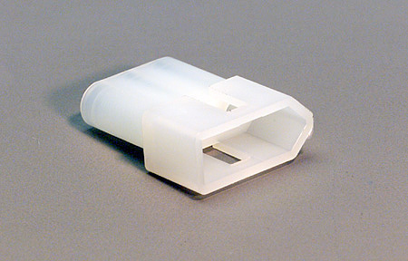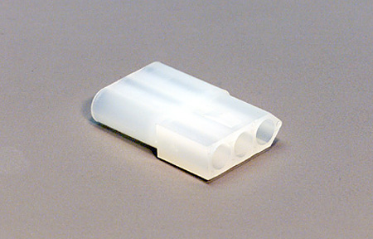

Battery and Alternator Connections
Big power leads like battery cables should have big lugs sweated on with a torch. Yup, with a torch. Dunk the lead in flux, heat it up and tin the exposed copper. Put some flux in the lug, get it hot and stick the tinned lead in. Add solder until the lug is full. The connection will be low resistance, won’t corrode and will look good. Wash the whole thing in water to remove any residual flux and put shrink tube over the whole shooting match to relieve the stress point where the solder made the wire solid.

First, take your solder and run off about 20 feet of it. Loop it around your hand and elbow like a rope and make 10 loops. Twist until you’ve got a thick bundle of solder. You can also buy bigger stuff, but why spend the money just to do two connectors?

As noted earlier, these are the only leads that won’t be #18 or #22. The Alternator lead will be #10 (up to 100 amps) and the battery leads are #2/0. That’s size 00, and I suggest using welding cable from your local welding supply house. Yes, it’s heavy, so make sure to keep these short. The amount of power wasted heating up start cables can be significant with today’s smaller batteries. It’s really worth using the big cables, and putting the battery close to the engine.

Coax Connectors
BNC connectors are about all you’ll see in light airplanes. Anything else, follow the instructions or get a pro to help you. There’s nothing magic about SMC, TNC or the rest, just no sense in beating yourself up to put on ONE oddball connector ONE time. You’ll do a few BNCs, though, and here’s what they look like:

The BNC – Digikey A24410-ND
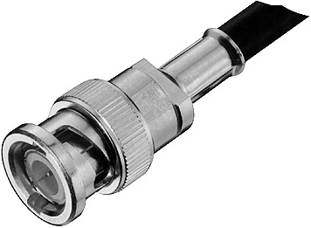

A step, by step professional guide to attaching these can be found on the ‘Net at:

http://www.extron.com/download/files/userman/cabtermkit-man.pdf

Learning To Solder
This is a better guide than I could write:

http://www.circuittechctr.com/guides/7-1-1.shtml

The only thing I’ll add is that solder and shrink tube come as a pair. If you solder a lead, it’s best to put shrink tube over the connection to keep it from oxidizing, and most importantly to strain relieve it. Solder makes stranded wire solid, and solid wires crack and break under vibration. Apply shrink tube from the solder joint out to where the wire is flexible (usually about an inch) and you’ll have a connection that’ll outlast the airframe.

Foolproof 100% Gonna Work Technique

The Standard Drawing

The Drawing for Your Project

Finding Problems and Correcting Mistakes

Foolproof 100% Gonna Work Power System

Power Board Design and Artwork
About 75% of the wiring in an airplane is the same whether you’re flying an RV, Cozy or a 7E7. You’ve got to have a way to turn things on and off, a place to connect up all your avionics and a few places to hook up things that come up with the Master switch like the Alternator field and panel lights.

I figured the obvious thing to do was build a circuit board: one place to connect it all.

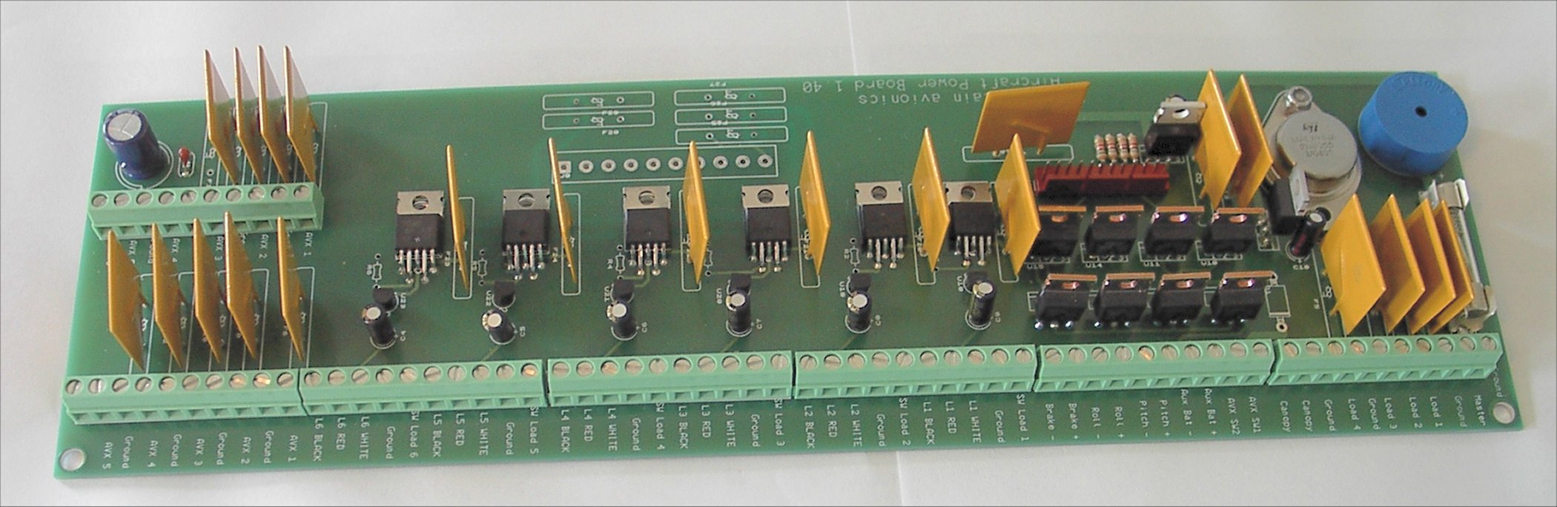

Here’s what we’ve got:

- Nine (9) circuits that come on with the Master switch
- Six (6) switched circuits with provision for driving backlit switch/ indicators
- Ten (10) filtered circuits that come on with the Avionics switch
- Provision for external Flap / Speed Brake switch

- 12 volt, 10 amp regulated power supply for Pitch and Roll trim motors and five (5) circuits 12 volt loads. Really nice to have in a 24 volt ship.

- Provision for connecting coolie hat to operate Pitch and Roll trim

- Runs on 10-32 volts DC
- Main power bus is fused at 35 Amperes
- All other circuits are individually protected by resettable PTC solid-state fuses

The power board is very simple – everything connects to it except your Master switch and Alternator output, which should be wired separately to the battery.

Here’s how to wire it (and the airplane) step by step:

Mounting the board

Mount the circuit board on standoffs board using 6-32 machine screws and LocTite. I used a piece of plywood, but fiberglass is fine. Metal is asking for trouble here!

Master Switch

Connect the your Master Switch to an external Master Relay with the output of that relay feeding the first lug on the powerboard. It’s marked MASTER. The reason for a separate switch and relay is in the event of a dropped screwdriver, you want a separate means of disconnecting the power board. Master Relays should be rated for continuous duty, and can be had from any number of aircraft suppliers. The reason I still recommend a mechanical master is that you can hear it thunk when you switch the master on or off, and your DAR may not approve a solid-state equivalent just yet.

Alternator output

The Alternator output should be connected directly to your battery through an appropriately sized circuit breaker. A fuse is also a reasonable choice here since the only reason this would blow is if the Alternator was running away and going over voltage, or if there was a fault large enough to damage the alternator. Either way, it’s not something you’d be likely to want to reset in flight.

Size this breaker or fuse for 1.25 times the rated Alternator output in Amperes.

Example: A 35 Amp alternator would get a 1.25 * 35 = 43.75 amp fuse. 50 is the next closest size in circuit breakers, or a 45 Amp fuse would do it. Remember, a fuse or breaker won’t hold above 80% of what it says on the nameplate; so a 50 Amp breaker will pop at 40 amps after 20 or 30 minutes. Just long enough into the flight to be a bother!

Here’s what the input section of the board looks like up close:

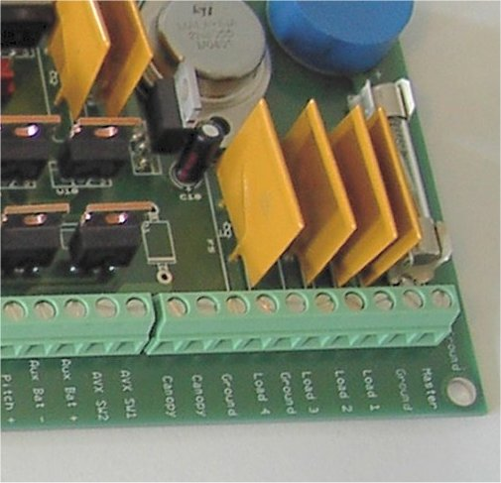

- Alternator Field and Master Circuits
The powerboard has Nine (9) circuits that come up with the Master switch. The first of these is usually the Alternator Field or Voltage Regulator. Connect this to one of the terminals on the first block with the Master, marked Load 1 through Load 4.

Switched loads

There are Six (6) switched loads that you can use for just about anything – lights, strobes, Pitot heat, de-ice, whatever you need. Simply connect the device to be powered to the Load and Ground terminals and the Switch to the color-coded switch terminals to turn it on and off. The PTC fuses will hold up to 9 Amperes on these loads, and will trip if anything shorts out.

The circled area shows the Load, Ground and switch terminals for the first of six switched loads:

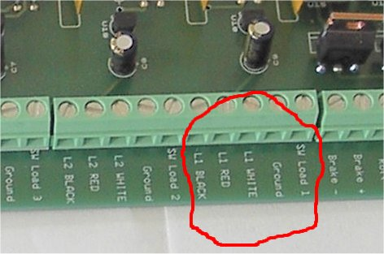

The circled are shows Switched Load 1, which is labeled SW Load 1 and Ground.

Color coding for the switch itself is also easy:

  - L1 RED is +5
  - L1 BLACK is ground
  - L1 WHITE is turns the circuit on or off.

So, connect a 5 volt lighted switch between RED and WHITE, and the light between WHITE and BLACK. That way, the switch lights up when it’s on, goes dark when the PTC blows, and can be reset to light up again when it resets.

Avionics Master and Backup Battery

I prefer my avionics to come up with the Master switch, so I installed a #18 jumper wire in the Avionics Switch terminals. If you want an Avionics Switch, this is where it goes – between AVX SW1 and AVX SW2.

If you are running a 12-volt system, you’ll want a backup battery to keep your electronics up and active during engine start. Connect it to the Aux Bat + and Aux Bat – terminals as shown below. It’s diode isolated and comes on and off with the avionics switch (or Master is you jumpered the avionics switch), so all you have to do is hook it up!

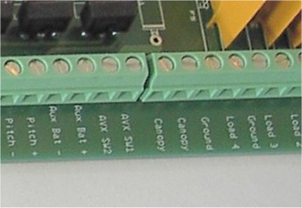

Avionics Loads

Each device hanging off the avionics buss will come on with the Avionics Master (or Master Switch if you jumpered it). You can connect up to ten (10) loads, which is usually sufficient for radios, EFIS, intercom, etc. Try and keep noisy things like motors and fans off this buss as it is filtered to keep the radios quiet.

Flaps, Pitch and Roll Trim

There is a KK Connector provided to hookup a coolie hat switch and a DPDT flap switch to drive a DC motor forward and backward for flaps or a dive brake or belly board. Connect the flap/brake motor to the terminals marked Brake+ and Brake-.

Flap and Trim Motor Voltages

I assume that you got the right voltage motor for your flaps, so whatever the battery voltage is, that’s what you’re going to get to the flap motor.

Now, 24 volt trim motors are a little hard to come by, and most people use trim servos like the Ray Allen (used to be MAC) which are 12 volt. That’s why trim circuits come from ther 12 volt regulated supply, regardless of input voltage. That’s right, you can use 12 volt trim motors even on a 23 volt airplane.

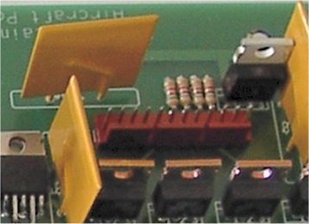

Pin 1 on the connector is nearest the right in the picture. Pinout is:

- Ground

- +5 volt power to coolie hat trim switch
- Pitch UP from coolie hat
- Pitch DOWN from coolie hat
- Roll LEFT from coolie hat
- Roll RIGHT from coolie hat

- +Aircraft power
- Ground

- +Flap Power to DPDT reversing switch (B in drawing below)
- –Flap Ground to DPDT reversing switch (E in drawing below)
- Flap Power UP from DPDT reversing switch (A in drawing below)
- Flap Ground UP from DPDT reversing switch (D in drawing below)

Wiring a Motor Reversing Switch

A reversing switch is made by simply connecting the DPDT switch so that the center poles take the input power and one pair of contacts take the output, with the other pair wired in reverse like this:

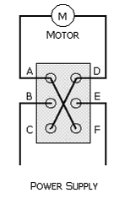

Pitch, Roll and Flap motors can be connected directly to the powerboard at the terminals provided. Pitch and Roll trim are 12 volts regulated at up to 10 Amps and is suitable for using 12 volt MAC servos (or similar) in 12 or 24 volts systems. The Flap circuit uses ship’s power and assumes the flap motor is the same voltage as the airplane’s battery.

Warning System

A pair of terminals is available on the first block for the Sonalert buzzer. You can run these to a switch, and when closed the Sonalert will beep intermittently until the switch is opened. This is great for canopy warning, gear warning, or whatever you need most.

That’s all there is to it. Connect up the Master switch, place a breaker for your Alternator and everything else goes to the board. Saves a lot of time, and ground loops just don’t happen. If you want to use the board, just drop me an email and I can either send you the board artwork to make your own, or a completed circuit board if that’s a better deal.

Power Board Schematic

For reference, here’s the schematic. Engineers will note the extensive use of PTCs and internally protected devices. I have assumed that eventually, almost anything will be crossed up with everything, and have tried to make the board as smoke-proof as practical.

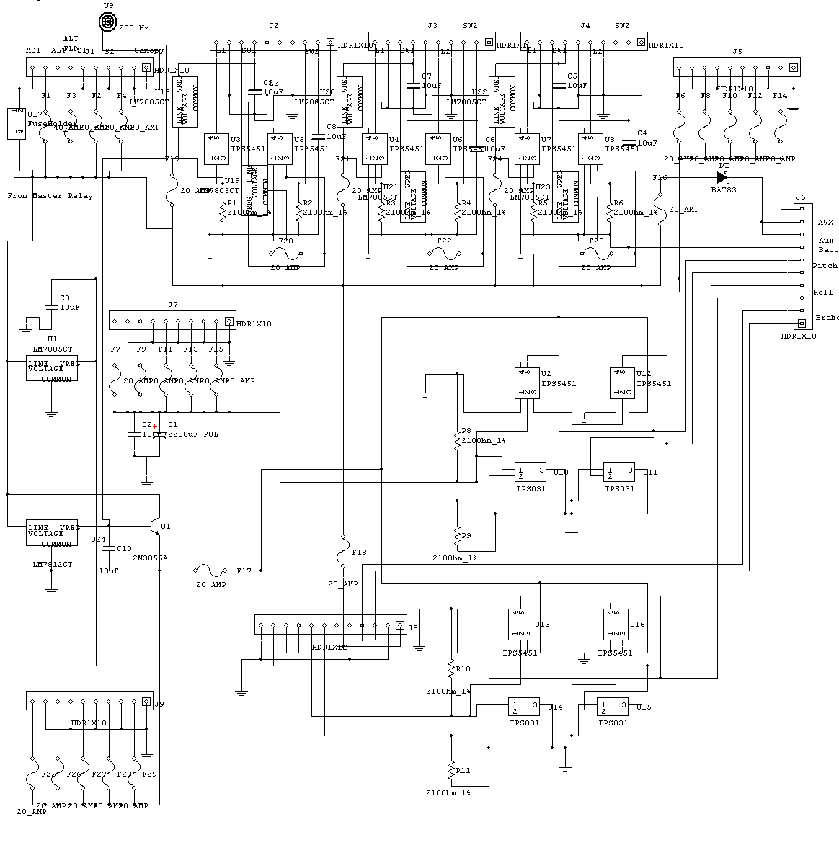

Where To Get Parts, Tools, Etc.
Digikey, at http://digikey.com has got everything you need in one place. Allied Electronics is also good at http://alliedelec.com , as is Mouser. Digikey has a great search feature on the Website that will really help you find things like “soldering iron” and show you a list and pictures without having to know the part numbers.

